

**COE457 Internet and IoT Programming**

**HW1**

**Academic Integrity Pledge**

|  |
| --- |
| As a student of American University of Sharjah, I here by state that I will abide by the AUS Integrity Pledge that:   * I will hold myself accountable for all that I say and write. * I will hold myself responsible for the academic integrity of my work * I will not carry out unauthorized copying or printing of the work of others * I will not misrepresent my work nor give or receive unauthorized aid * I will behave in a manner that demonstrates concern for the personal dignity, rights and freedoms of all members of the community * I will respect university property and the property of others; and * I will not tolerate a lack of respect for these values.   **Student Name: Dhriti Adyanthaya**  **Student IDs: g00074266** |

# Link

<https://github.com/dhritix1999/Dhriti-s_Portfolio>

# Screenshots

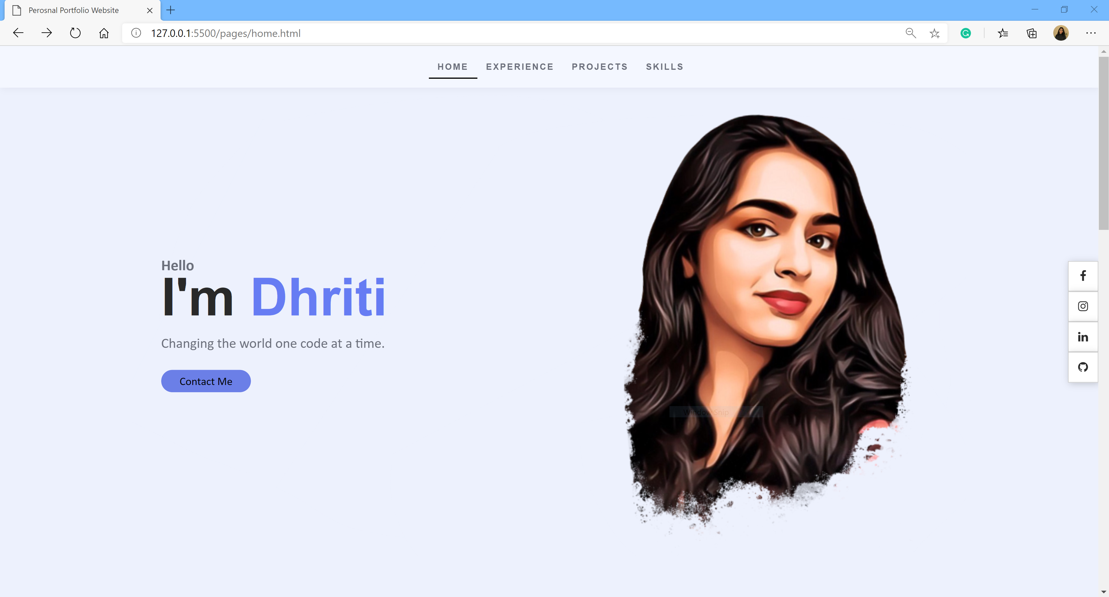

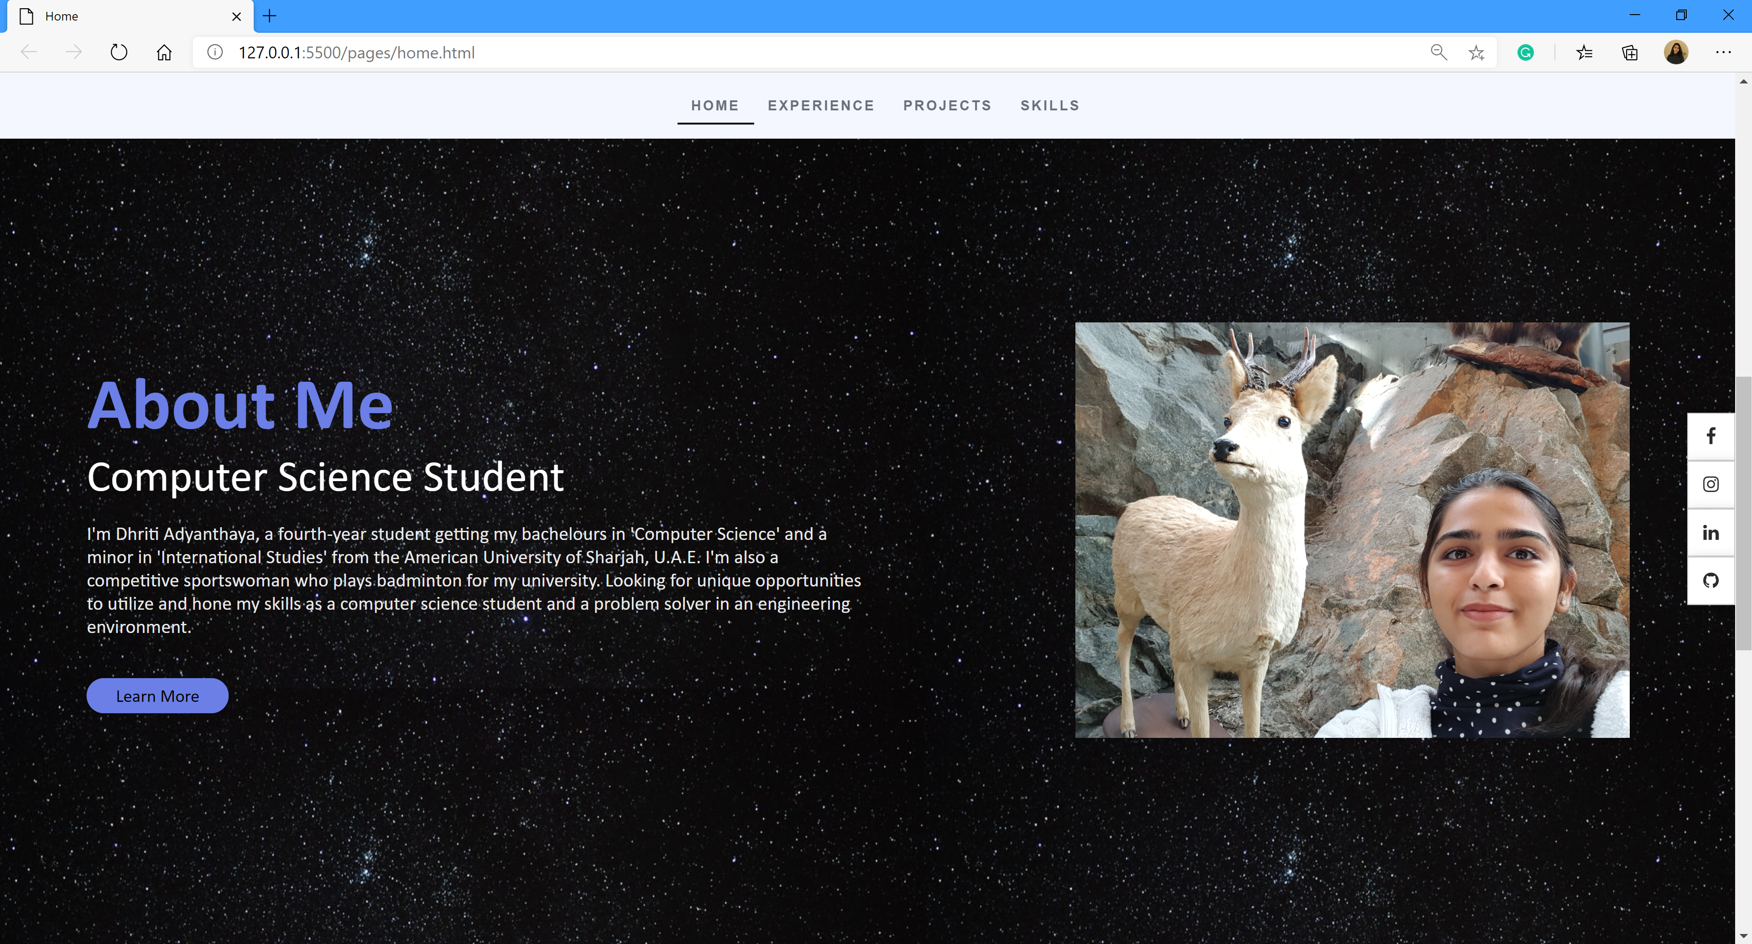

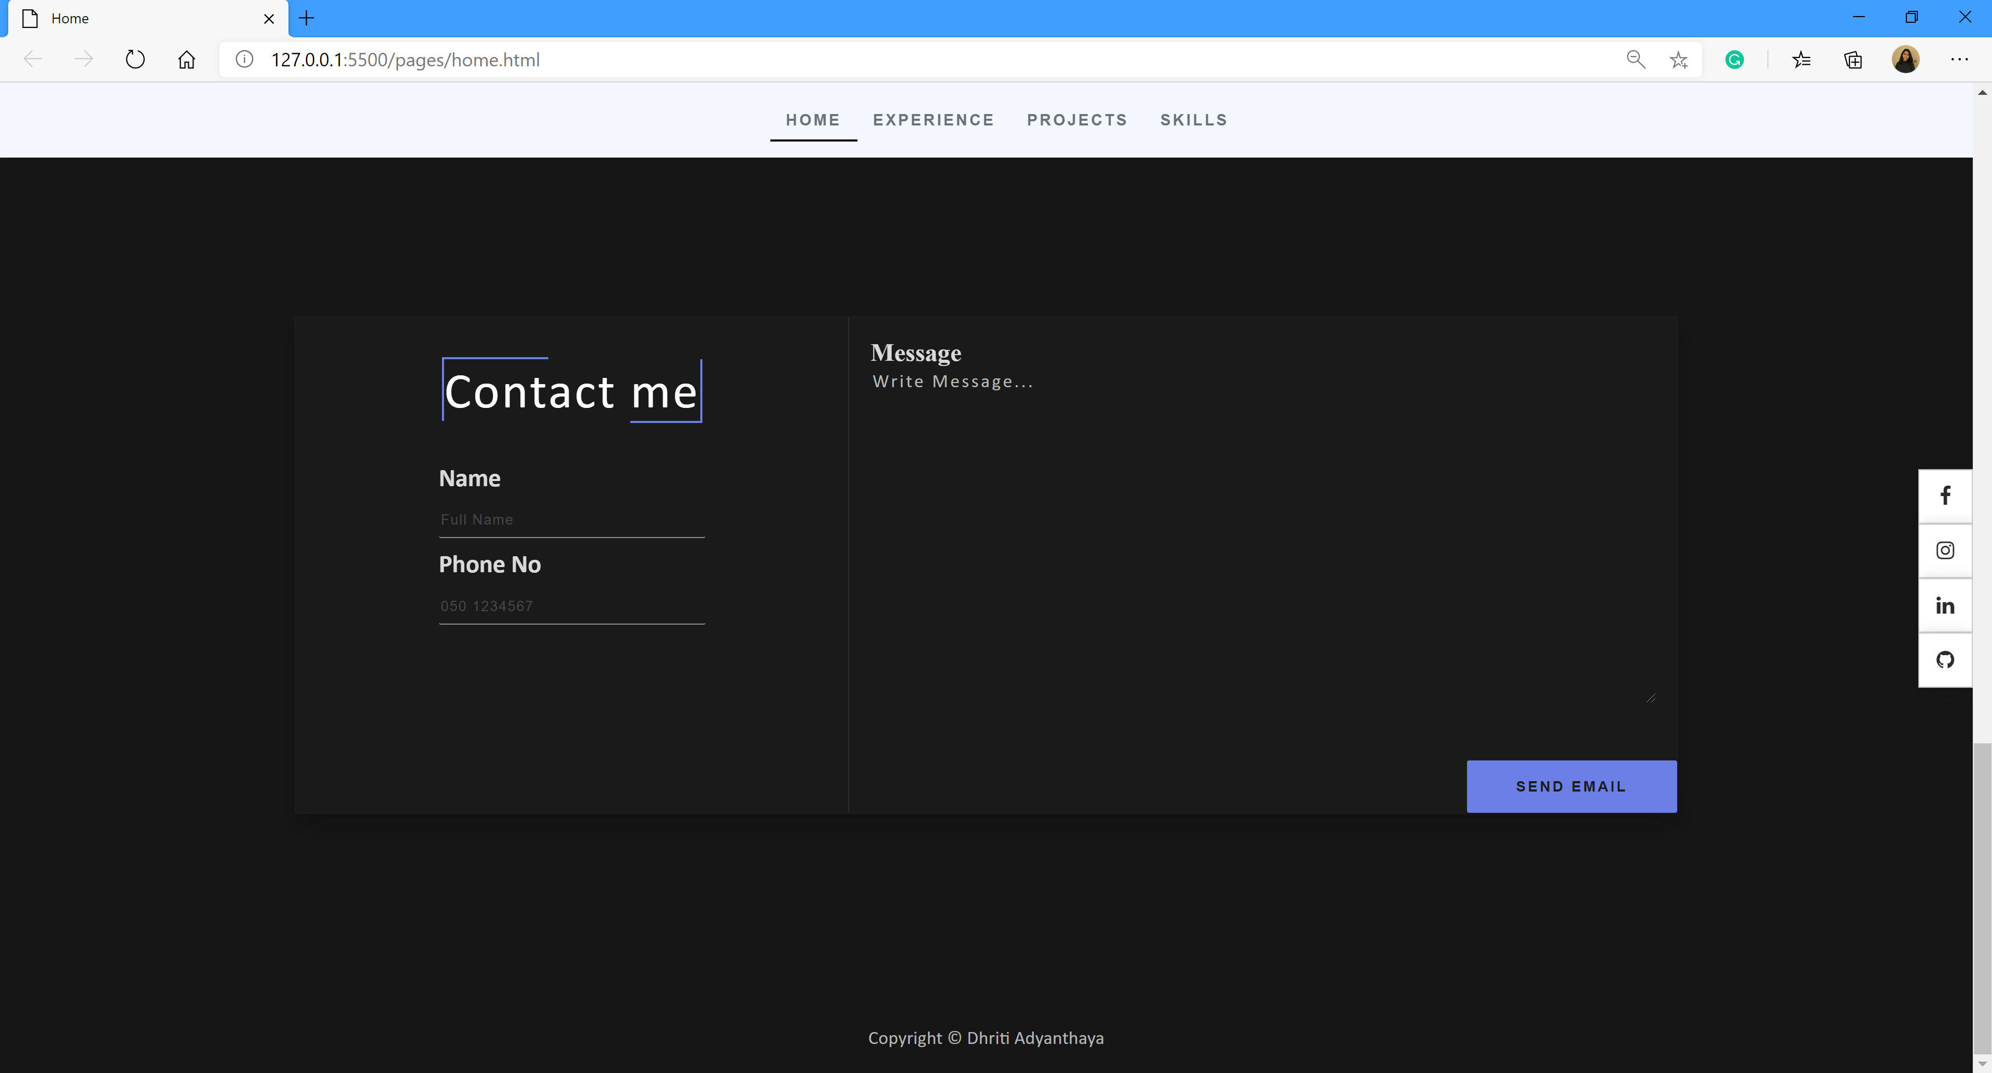

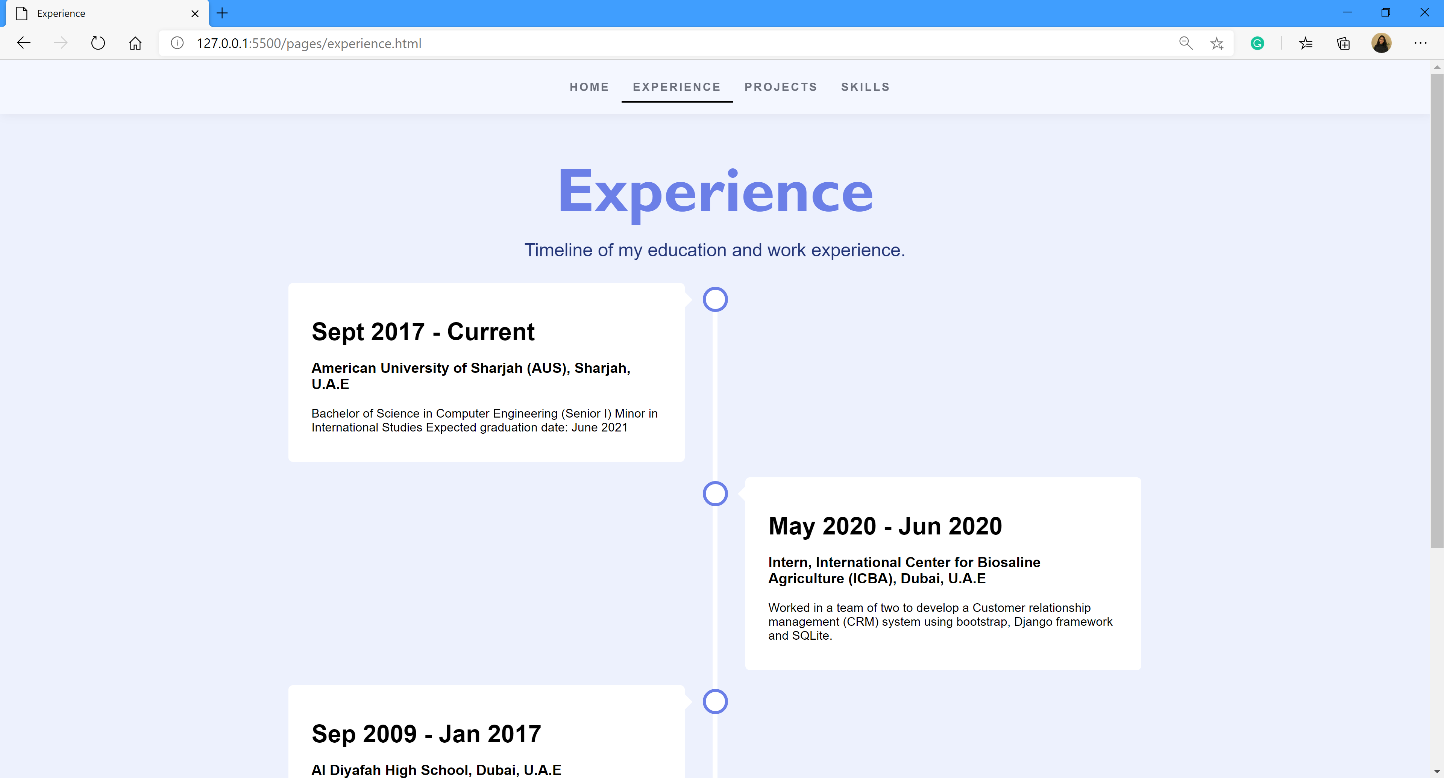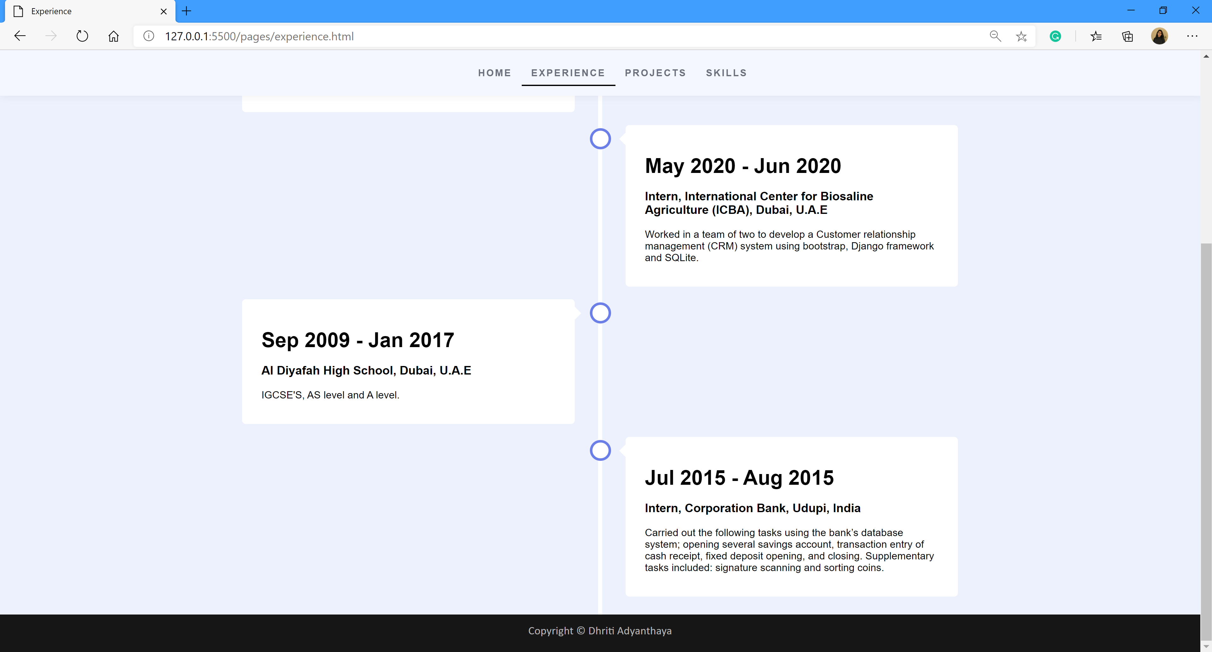

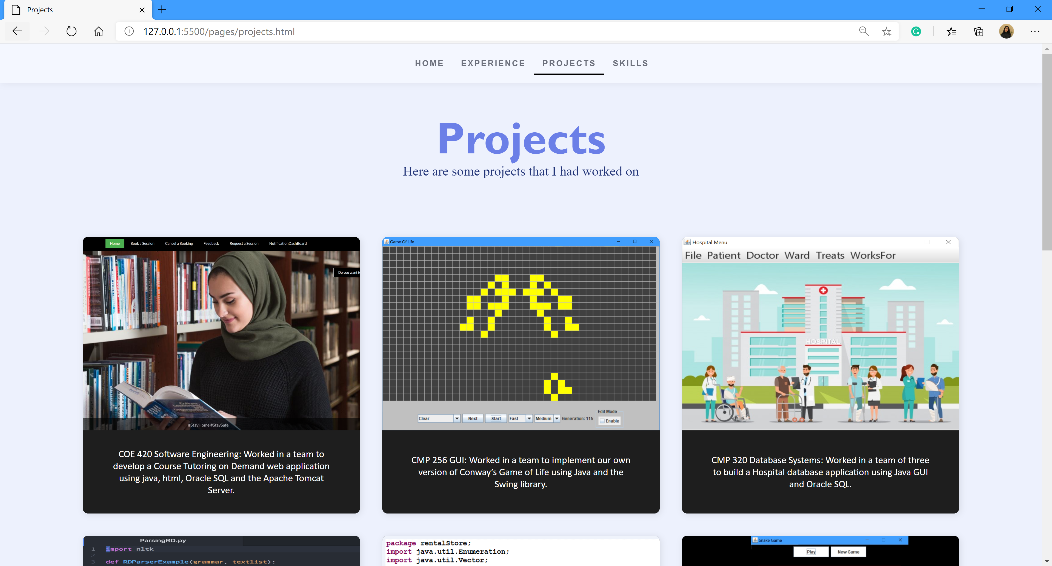

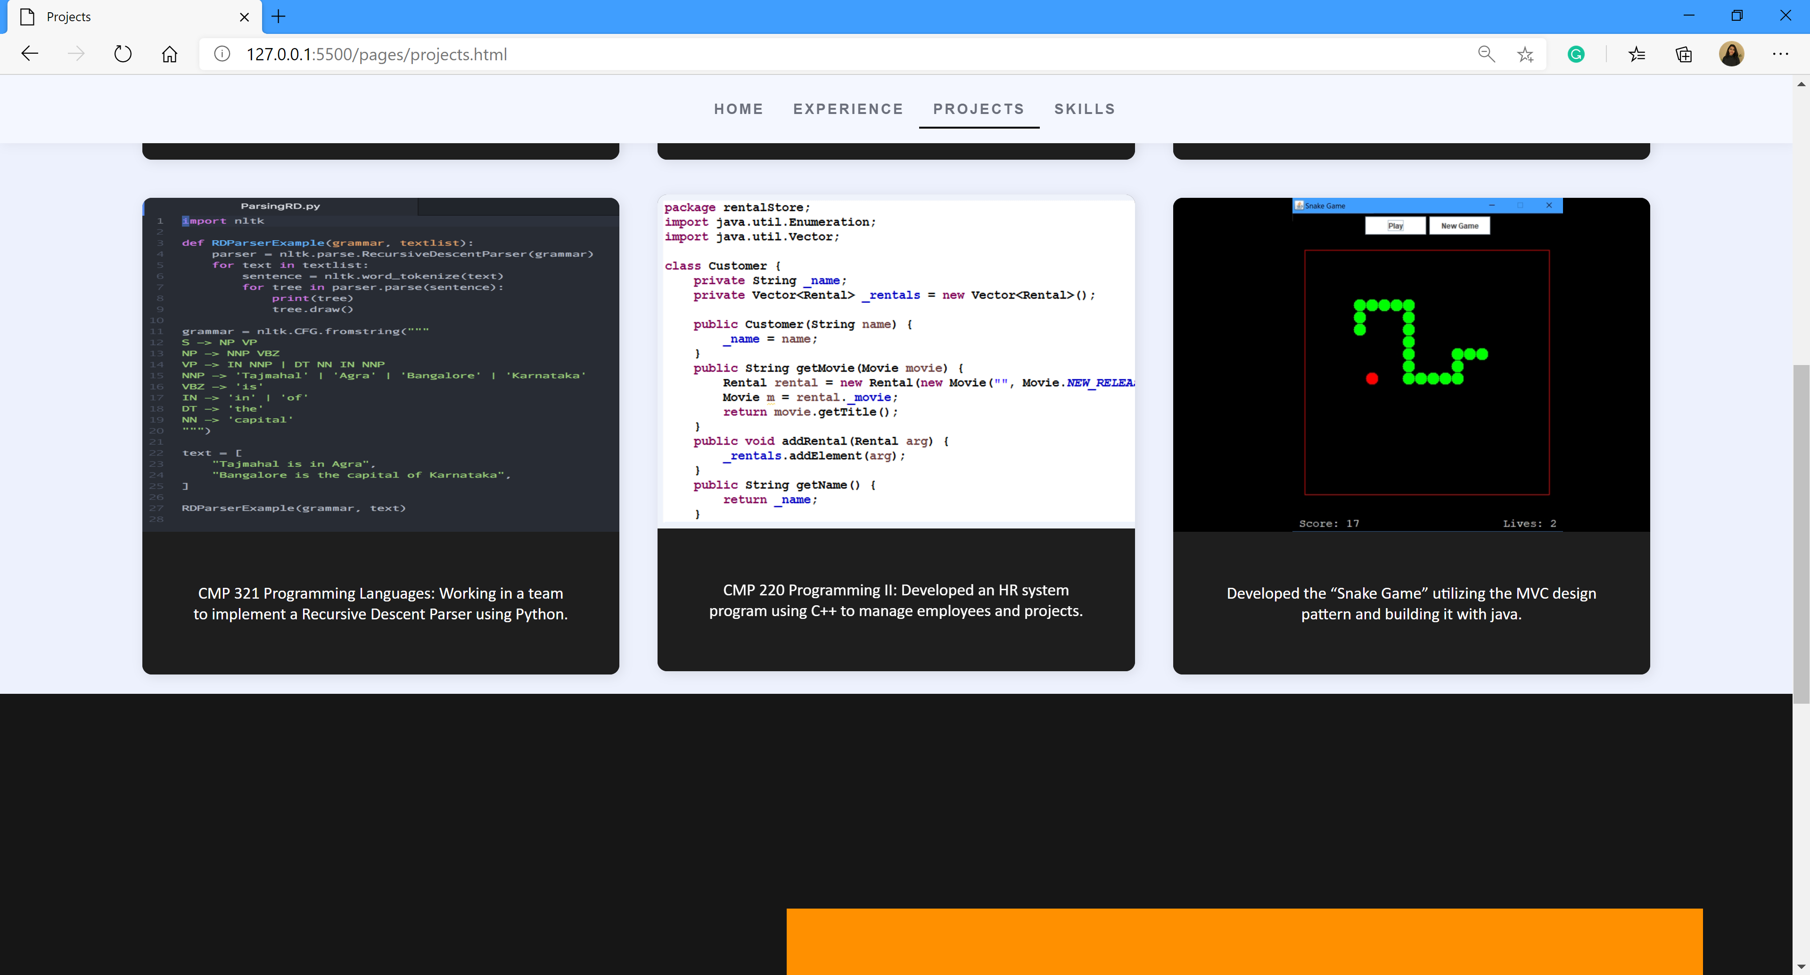

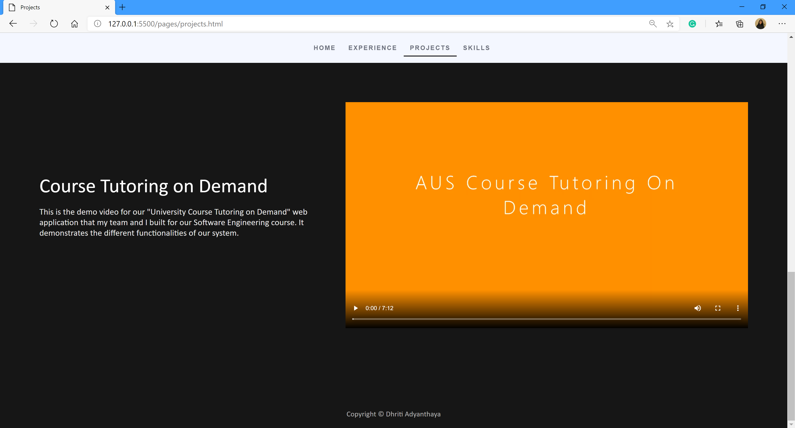

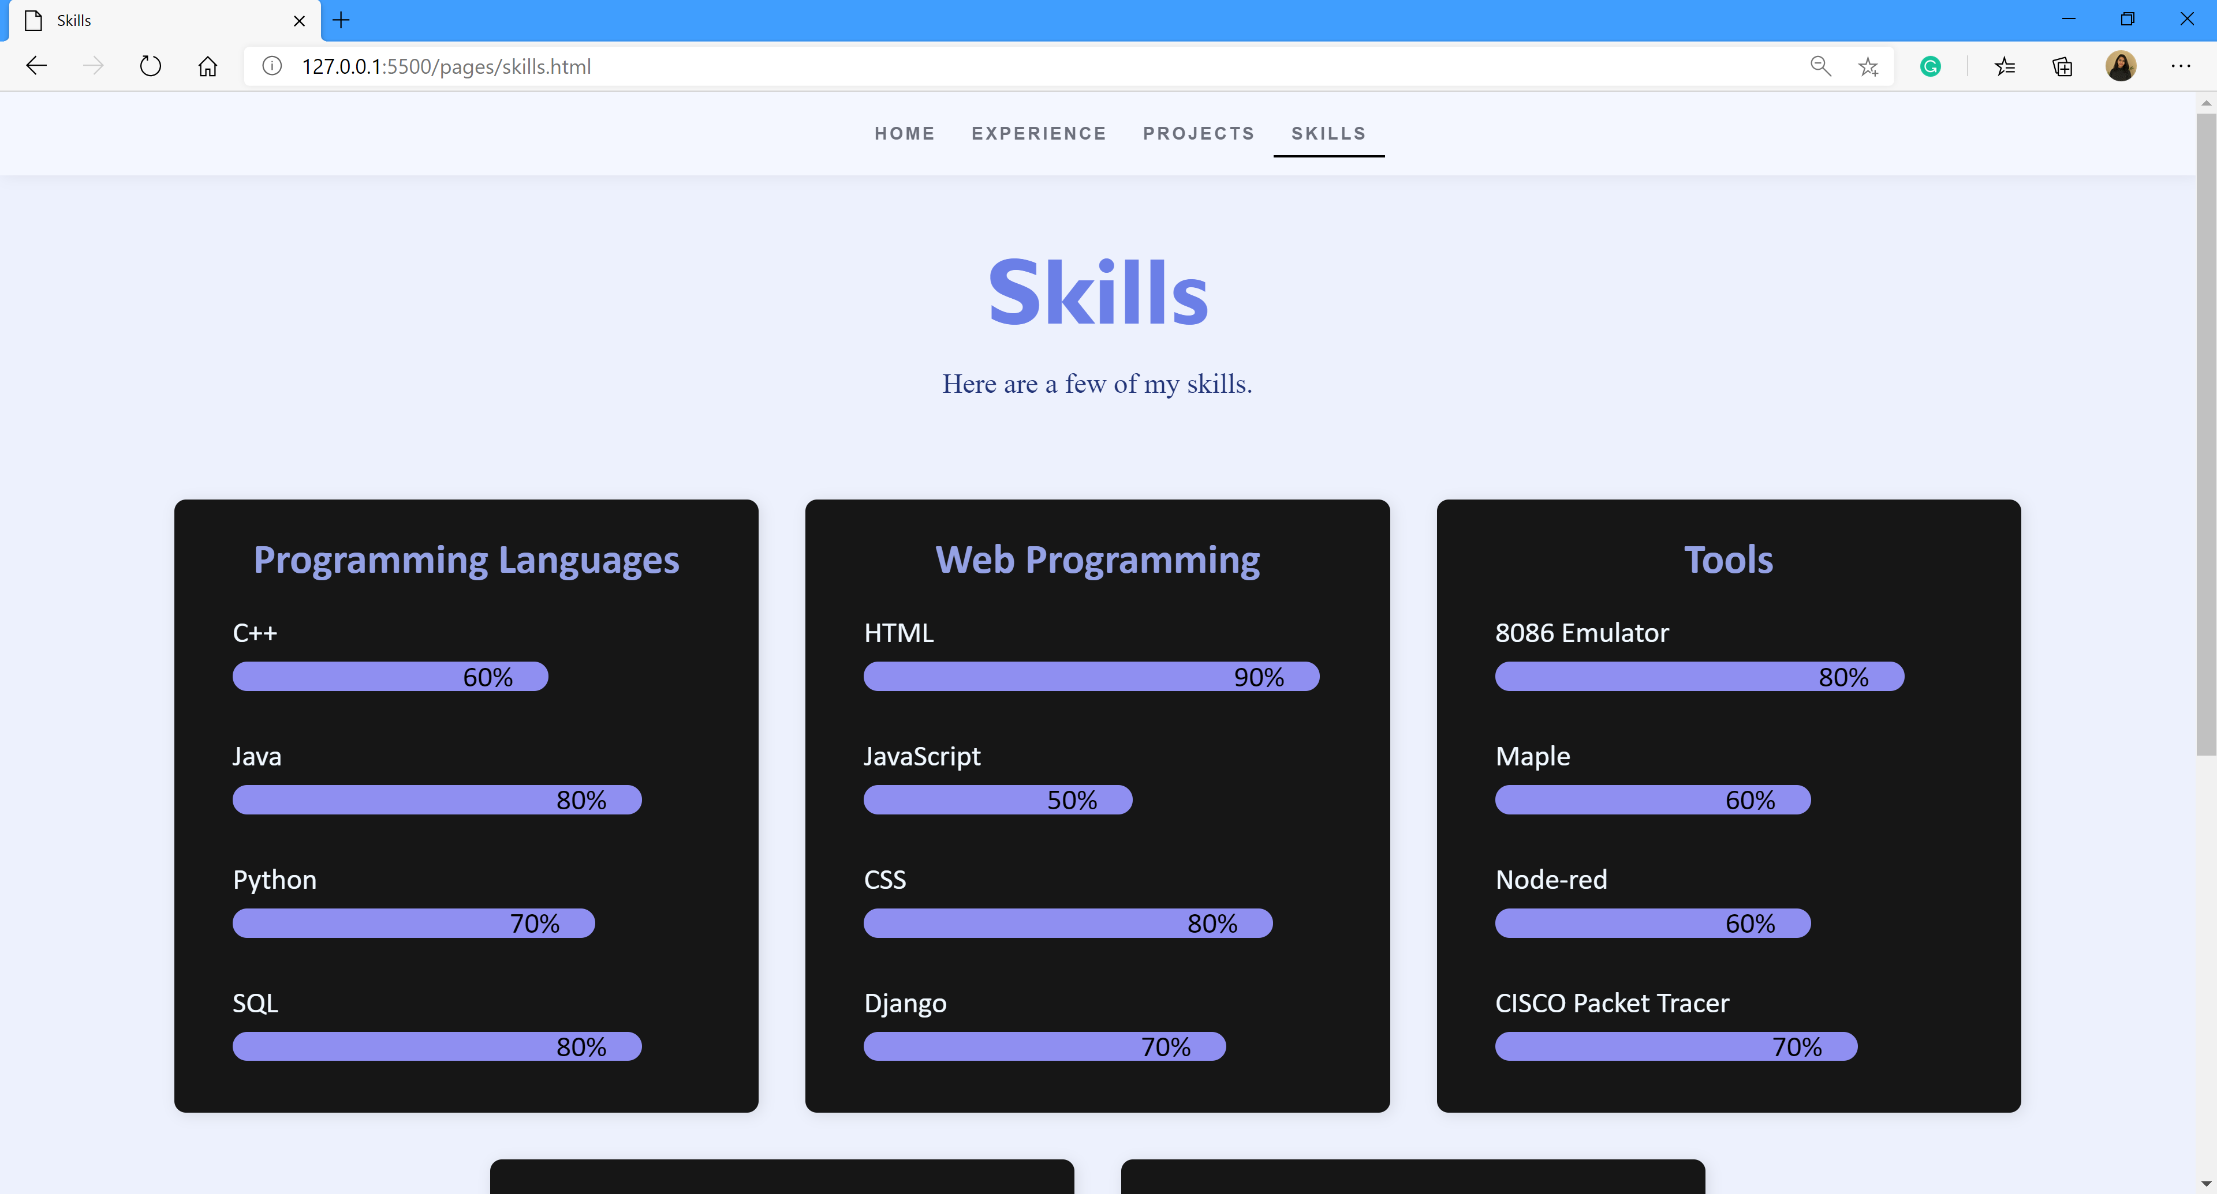

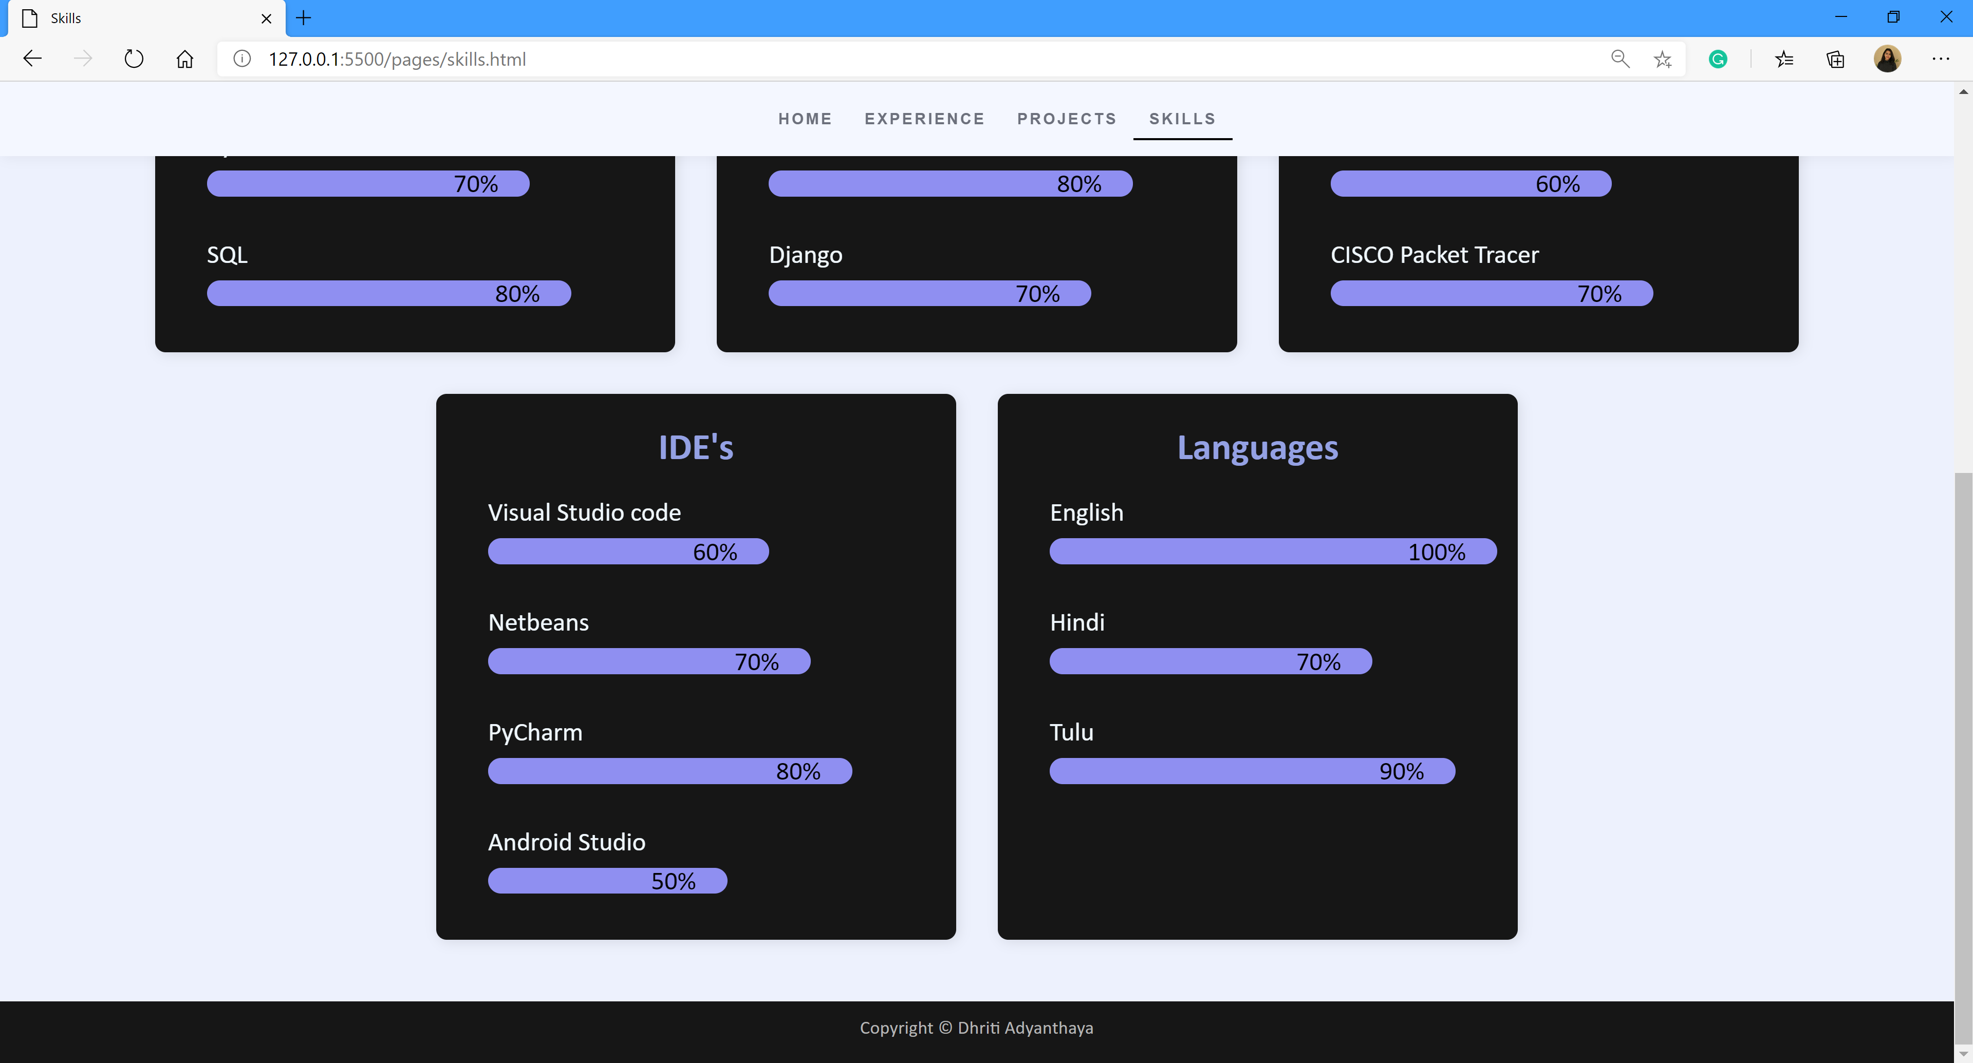

# HTML

## Home

<!DOCTYPE html>

<html lang="en">

<head>

<meta charset="utf-8">

<title>Home</title>

<meta http-equiv="X-UA-Compatible" content="IE-edge">

<meta name="viewport" content="width=device-width, initial-scale=1.0">

<!--title-icon--------->

<link rel="shortcut icon" href="images/icon.png">

<link rel="stylesheet" type="text/css" href="/stylings/base.css"/>

<link rel="stylesheet" type="text/css" href="/stylings/home.css"/>

<link rel="stylesheet" href="https://cdnjs.cloudflare.com/ajax/libs/font-awesome/4.7.0/css/font-awesome.min.css">

</head>

<body>

 <section id="main">

 <!--navigation-------------------------------->

 <nav>

<div></div>

 <!--menu--------->

 <div class="toggle"></div>

 <ul class="menu">

 <li class="active"><a href="#" >Home</a></li>

 <li><a href="/pages/experience.html">Experience</a></li>

 <li><a href="/pages/projects.html">Projects</a></li>

 <li><a href="/pages/skills.html">Skills</a></li>

 </ul>

 <div></div>

 </nav>

 <!--name--------------------------->

 <div class="name">

 <h2 style="font-size: 26px; color: #6c707c;">Hello</h2>

 <h1>I'm <mark class="purple">Dhriti</mark></h1>

 <p class="details">Changing the world one code at a time.</p>

 <element class="about-text">

   <a class="button" href="#contact-form">Contact Me</a>

 </element>

 </div>

 </section>

 <!--about----------------------->

  <section id="about">

 <!--text---------------------->

 <div class="about-text">

 <h1>About Me</h1>

 <h2>Computer Science Student</h2>

 <p>I'm Dhriti Adyanthaya, a fourth-year student getting my bachelours in 'Computer Science' and a minor in 'International Studies' from the American University of Sharjah, U.A.E. I'm also a competitive sportswoman who plays badminton for my university. Looking for unique opportunities to utilize and hone my skills as a computer science student and a problem solver in an engineering environment.</p>

 <a class="button" href="/pages/experience.html">Learn More</a>

 </div>

 <!--about-model----------------->

 <div class="about-model">

 <img alt="model" src="/images/dhriti2.jpg"/>

 </div>

 </section>

 <!--contact-form------------------->

 <section id="contact-form">

 <form action="mailto:dhritiadyanthaya14@gmail.com"

    method="POST"

    enctype="text/plain">

 <!--left--------------------------------------->

 <div class="contact-left">

 <h1 class="c-l-heading"> <font style="border-top: 2px solid #6b7fe7; border-left: 2px solid #6b7fe7;">Cont</font>act <font style="border-bottom: 2px solid #6b7fe7;border-right: 2px solid #6b7fe7;">me</font></h1>

 <!--name-------->

 <div class="f-name">

 <h2 style="color: #d9d9d9;">Name</h2>

 <input type="text" name="Name" placeholder="Full Name"/>

 </div>

 <!--email-------->

 <div class="f-number">

 <h2 style="color: #d9d9d9;" >Phone No</h2>

 <input type="text" name="Contact Number" placeholder="050 1234567"/>

 </div>

 </div>

 <!--right------------------------------------------->

 <div class="contact-right">

 <!--message-------->

 <div class="message">

 <h2 style="color: #d9d9d9;">Message</h2>

 <textarea name="message" rows="5" cols="20" placeholder="Write Message..."></textarea>

 </div>

 <!--submit-btn------------>

<input type="submit" value="Send Email">

 </div>

 </form>

 </section>

 <footer>

   <!--copyright-->

   <p class="copyright">Copyright &copy; Dhriti Adyanthaya</p>

</footer>

<div class="social">

   <a href="https://www.facebook.com/dhriti.adyanthaya"><i class="fa fa-facebook-f"></i></a>

   <a href="https://www.instagram.com/dhritix1999/"><i class="fa fa-instagram"></i></a>

   <a href="https://www.linkedin.com/in/dhriti-adyanthaya-9b5277122/"><i class="fa fa-linkedin"></i></a>

   <a href="https://github.com/dhritix1999"><i class="fa fa-github"></i></a>

   </div>

</body>

</html>

## Project

<!DOCTYPE html>

<html lang="en">

<head>

<meta charset="utf-8">

<title>Projects</title>

<meta http-equiv="X-UA-Compatible" content="IE-edge">

<meta name="viewport" content="width=device-width, initial-scale=1.0">

<!--title-icon--------->

<link rel="shortcut icon" href="images/icon.png">

<link rel="stylesheet" type="text/css" href="/stylings/base.css"/>

<link rel="stylesheet" type="text/css" href="/stylings/projects.css"/>

<link rel="stylesheet" href="https://cdnjs.cloudflare.com/ajax/libs/font-awesome/4.7.0/css/font-awesome.min.css">

</head>

<body>

 <!--navigation-->

 <nav>

<div></div>

 <!--menu--------->

 <div class="toggle"></div>

 <ul class="menu">

 <li><a href="/pages/home.html" >Home</a></li>

 <li><a href="/pages/experience.html">Experience</a></li>

 <li class="active"><a href="#">Projects</a></li>

 <li><a href="/pages/skills.html">Skills</a></li>

 </ul>

 <div></div>

 </nav>

<div class="project-text">

<h1>Projects</h1>

<h2>Here are some projects that I had worked on </h2>

</div>

 <section id="services">

    <!--container--------->

    <div class="b-container">

    <!--box-1---->

            <div class="s-box">

            <div class="s-b-img">

            <img style="   height: 100%;

            margin-left: -25%;" src="https://user-images.githubusercontent.com/50911194/82947603-61610f00-9fb1-11ea-9934-36dabd27d276.PNG">

            </div>

            <!--text------>

            <div class="s-b-text">

            <a href="https://github.com/COE420-SE/Course-Tutoring-On-Demand">COE 420 Software Engineering: Worked in a team to develop a Course Tutoring on Demand web application using java, html, Oracle SQL and the Apache Tomcat Server.</a>

            </div>

            </div>

     <!--box-2---->

     <div class="s-box">

        <div class="s-b-img">

        <img style="   height: 100%; width:100%" src="https://user-images.githubusercontent.com/50911194/88464922-a7622280-cecf-11ea-852b-3b6f10fbaf9c.PNG">

        </div>

        <!--text------>

        <div class="s-b-text">

        <a href="https://github.com/Zaid-R98/GUI-Project">CMP 256 GUI: Worked in a team to implement our own version of Conway’s Game of Life using Java and the Swing library.</a>

        </div>

        </div>

     <!--box-3---->

            <div class="s-box">

            <div class="s-b-img">

            <img style="   height: 100%; width:100%" src="https://user-images.githubusercontent.com/50911194/88394827-1efd5800-cdd1-11ea-9da7-7c7c886311a7.png">

            </div>

            <!--text--->

            <div class="s-b-text">

            <a href="https://github.com/dhritix1999/HospitalDBMS">CMP 320 Database Systems: Worked in a team of three to build a Hospital database application using Java GUI and Oracle SQL.</a>

            </div>

            </div>

    </div>

    <div class="b-container">

        <!--box-4---------------->

                <div class="s-box">

                <div class="s-b-img">

                <img style="height:100%;   width: 100%;" src="https://static.packt-cdn.com/products/9781787289321/graphics/78a4a37f-0627-4b72-99b3-9a52dc66df4e.png">

                </div>

                <!--text----->

                <div class="s-b-text">

                <a href="https://github.com/asifrasheed6/Prolog-Parser">CMP 321 Programming Languages: Working in a team to implement a Recursive Descent Parser using Python.</a>

                </div>

                </div>

         <!--box-5------->

                <div class="s-box">

                <div class="s-b-img" style="background-color:black;">

                <img style="   height: 100%;" src="https://www.researchgate.net/profile/Md_Masudur_Rahman9/publication/317401664/figure/fig2/AS:504826271408129@1497371370743/Source-Code-Example-Customerjava-Partial.png">

                </div>

                <!--text----->

                <div class="s-b-text">

                <a href="#">CMP 220 Programming II: Developed an HR system program using C++ to manage employees and projects.</a>

                </div>

                </div>

         <!--box-6--->

         <div class="s-box">

            <div class="s-b-img" style="background-color:black;">

            <img style="   height: 100%;

            margin-left: 25%;" src="https://github.com/dhritix1999/Snake-Game-MVC/raw/master/snakeee.PNG">

            </div>

            <!--text------>

            <div class="s-b-text">

            <a href="https://github.com/dhritix1999/Snake-Game-MVC">Developed the “Snake Game” utilizing the MVC design pattern and building it with java.</a>

            </div>

            </div>

        </div>

    </section>

<!--about----------------------->

 <section id="about">

<!--text---------------------->

<div class="about-text">

<h2>Course Tutoring on Demand</h2>

<p>This is the demo video for our "University Course Tutoring on Demand" web application that my team and I built for our Software Engineering course. It demonstrates the different functionalities of our system.</p>

</div>

<!--about-model----------------->

<div class="about-model">

    <video width="960" height="540" controls>

        <source src="/images/Final Demo.mp4" type="video/mp4">

        Your browser does not support the video tag.

      </video>

</div>

</section>

 <footer>

   <!--copyright-->

   <p class="copyright">Copyright &copy; Dhriti Adyanthaya</p>

</footer>

</body>

</html>

## Experience

<!--doctype html-->

<html>

<head>

<meta charset="utf-8">

<title>Experience</title>

<meta http-equiv="X-UA-Compatible" content="IE-edge">

<meta name="viewport" content="width=device-width, initial-scale=1.0">

<!--title-icon--------->

<link rel="shortcut icon" href="images/icon.png">

<link rel="stylesheet" type="text/css" href="/stylings/base.css"/>

<link rel="stylesheet" type="text/css" href="/stylings/experience.css"/>

<link rel="stylesheet" href="https://cdnjs.cloudflare.com/ajax/libs/font-awesome/4.7.0/css/font-awesome.min.css">

</head>

<body>

 <!--navigation-------------------------------->

 <nav>

<div></div>

 <!--menu--------->

 <div class="toggle"></div>

 <ul class="menu">

 <li><a href="/pages/home.html" >Home</a></li>

 <li class="active"><a href="#">Experience</a></li>

 <li><a href="/pages/projects.html">Projects</a></li>

 <li><a href="/pages/skills.html">Skills</a></li>

 </ul>

 <div></div>

 </nav>

 <!--name--------------------------->

<div class="experience-text">

<h1>Experience</h1>

<h2>Timeline of my education and work experience. </h2>

</div>

    <div class="timeline">

        <div class="container left">

            <div class="content">

                <h2>Sept 2017 - Current</h2>

                <h3>American University of Sharjah (AUS), Sharjah, U.A.E</h3>

                <p>Bachelor of Science in Computer Engineering (Senior I) Minor in International Studies

                    Expected graduation date: June 2021</p>

              </div>

        </div>

        <div class="container right">

            <div class="content">

                <h2>May 2020 - Jun 2020</h2>

                <h3>Intern, International Center for Biosaline Agriculture (ICBA), Dubai, U.A.E</h3>

                <p>Worked in a team of two to develop a Customer relationship management (CRM) system using bootstrap, Django framework and SQLite.</p>

              </div>

        </div>

        <div class="container left">

            <div class="content">

                <h2>Sep 2009 - Jan 2017</h2>

                <h3>Al Diyafah High School, Dubai, U.A.E</h3>

                <p>IGCSE'S, AS level and A level.</p>

              </div>

        </div>

        <div class="container right">

            <div class="content">

                <h2>Jul 2015 - Aug 2015</h2>

                <h3>Intern, Corporation Bank, Udupi, India</h3>

                <p>Carried out the following tasks using the bank’s database system; opening several savings account, transaction entry of cash receipt, fixed deposit opening, and closing.

                    Supplementary tasks included: signature scanning and sorting coins.</p>

              </div>

        </div>

      </div>

      <br>

 <footer>

   <!--copyright-->

   <p class="copyright">Copyright &copy; Dhriti Adyanthaya</p>

</footer>

</body>

</html>

## Skills

<!DOCTYPE html>

<html lang="en">

<head>

<meta charset="utf-8">

<title>Skills</title>

<meta http-equiv="X-UA-Compatible" content="IE-edge">

<meta name="viewport" content="width=device-width, initial-scale=1.0">

<!--title-icon--------->

<link rel="stylesheet" type="text/css" href="/stylings/base.css"/>

<link rel="stylesheet" type="text/css" href="/stylings/skill.css"/>

<link rel="stylesheet" href="https://cdnjs.cloudflare.com/ajax/libs/font-awesome/4.7.0/css/font-awesome.min.css">

</head>

<body>

 <!--navigation-->

 <nav>

<div></div>

 <!--menu--------->

 <div class="toggle"></div>

 <ul class="menu">

 <li><a href="/pages/home.html" >Home</a></li>

 <li><a href="/pages/experience.html">Experience</a></li>

 <li><a href="/pages/projects.html">Projects</a></li>

 <li class="active"><a href="#">Skills</a></li>

 </ul>

 <div></div>

 </nav>

<div class="project-text">

<h1>Skills</h1>

<h2>Here are a few of my skills. </h2>

</div>

 <section id="services">

    <!--container--------->

    <div class="b-container">

    <!--box-1---->

            <div class="s-box">

            <div class="skills">

                <h2>Programming Languages</h2>

            </div>

            <!--text------>

            <div class="skills-area">

                <div class="skill">

                  <div class="skill-title">C++</div>

                  <div class="skill-bar"></div>

                  <div class="h-60 skill-fill">

                    <span class="skill-percent">60%</span>

                  </div>

                </div>

                <div class="skill">

                  <div class="skill-title">Java</div>

                  <div class="skill-bar"></div>

                  <div class="h-80 skill-fill">

                    <span class="skill-percent">80%</span>

                  </div>

                </div>

                <div class="skill">

                  <div class="skill-title">Python</div>

                  <div class="skill-bar"></div>

                  <div class="h-70 skill-fill">

                    <span class="skill-percent">70%</span>

                  </div>

                </div>

                <div class="skill">

                    <div class="skill-title">SQL</div>

                    <div class="skill-bar"></div>

                    <div class="h-80 skill-fill">

                      <span class="skill-percent">80%</span>

                    </div>

                  </div>

              </div>

            </div>

 <!--box-2---->

                <div class="s-box">

                    <div class="skills">

                        <h2>Web Programming</h2>

                    </div>

                    <!--text------>

                    <div class="skills-area">

                        <div class="skill">

                          <div class="skill-title">HTML</div>

                          <div class="skill-bar"></div>

                          <div class="h-90 skill-fill">

                            <span class="skill-percent">90%</span>

                          </div>

                        </div>

                        <div class="skill">

                          <div class="skill-title">JavaScript</div>

                          <div class="skill-bar"></div>

                          <div class="h-50 skill-fill">

                            <span class="skill-percent">50%</span>

                          </div>

                        </div>

                        <div class="skill">

                          <div class="skill-title">CSS</div>

                          <div class="skill-bar"></div>

                          <div class="h-80 skill-fill">

                            <span class="skill-percent">80%</span>

                          </div>

                        </div>

                        <div class="skill">

                            <div class="skill-title">Django</div>

                            <div class="skill-bar"></div>

                            <div class="h-70 skill-fill">

                              <span class="skill-percent">70%</span>

                            </div>

                          </div>

                      </div>

                    </div>

         <!--box-3---->

    <div class="s-box">

                <div class="skills">

                    <h2>Tools</h2>

                </div>

                <!--text------>

                <div class="skills-area">

                    <div class="skill">

                      <div class="skill-title">8086 Emulator</div>

                      <div class="skill-bar"></div>

                      <div class="h-80 skill-fill">

                        <span class="skill-percent">80%</span>

                      </div>

                    </div>

                    <div class="skill">

                      <div class="skill-title">Maple</div>

                      <div class="skill-bar"></div>

                      <div class="h-60 skill-fill">

                        <span class="skill-percent">60%</span>

                      </div>

                    </div>

                    <div class="skill">

                      <div class="skill-title">Node-red</div>

                      <div class="skill-bar"></div>

                      <div class="h-60 skill-fill">

                        <span class="skill-percent">60%</span>

                      </div>

                    </div>

                    <div class="skill">

                        <div class="skill-title">CISCO Packet Tracer</div>

                        <div class="skill-bar"></div>

                        <div class="h-70 skill-fill">

                          <span class="skill-percent">70%</span>

                        </div>

                      </div>

                  </div>

                </div>

        </div>

<!-- 2nd row -->

        <div class="b-container">

            <!--box-4---->

                    <div class="s-box">

                    <div class="skills">

                        <h2>IDE's</h2>

                    </div>

                    <!--text------>

                    <div class="skills-area">

                        <div class="skill">

                          <div class="skill-title">Visual Studio code</div>

                          <div class="skill-bar"></div>

                          <div class="h-60 skill-fill">

                            <span class="skill-percent">60%</span>

                          </div>

                        </div>

                        <div class="skill">

                            <div class="skill-title">Netbeans</div>

                            <div class="skill-bar"></div>

                            <div class="h-70 skill-fill">

                              <span class="skill-percent">70%</span>

                            </div>

                          </div>

                        <div class="skill">

                          <div class="skill-title">PyCharm</div>

                          <div class="skill-bar"></div>

                          <div class="h-80 skill-fill">

                            <span class="skill-percent">80%</span>

                          </div>

                        </div>

                        <div class="skill">

                            <div class="skill-title">Android Studio</div>

                            <div class="skill-bar"></div>

                            <div class="h-50 skill-fill">

                              <span class="skill-percent">50%</span>

                            </div>

                          </div>

                      </div>

                    </div>

         <!--box-2---->

                        <div class="s-box">

                            <div class="skills">

                                <h2>Languages</h2>

                            </div>

                            <!--text------>

                            <div class="skills-area">

                                <div class="skill">

                                  <div class="skill-title">English</div>

                                  <div class="skill-bar"></div>

                                  <div class="h-100 skill-fill">

                                    <span class="skill-percent">100%</span>

                                  </div>

                                </div>

                                <div class="skill">

                                  <div class="skill-title">Hindi</div>

                                  <div class="skill-bar"></div>

                                  <div class="h-70 skill-fill">

                                    <span class="skill-percent">70%</span>

                                  </div>

                                </div>

                                <div class="skill">

                                  <div class="skill-title">Tulu</div>

                                  <div class="skill-bar"></div>

                                  <div class="h-90 skill-fill">

                                    <span class="skill-percent">90%</span>

                                  </div>

                                </div>

                              </div>

                            </div>

                </div>

        <br>

        <br>

    </section>

 <footer>

   <!--copyright-->

   <p class="copyright">Copyright &copy; Dhriti Adyanthaya</p>

</footer>

</body>

</html>

# CSS

## Base

@charset "utf-8";

/* CSS Document */

body{

 margin:0px;

 padding:0px;

 background-color:#161616;

}

ul{

 list-style:none;

}

a{

 text-decoration:none;

}

mark.purple{

  color: #667cf3;

  background: none;

}

nav{

 display:flex;

 justify-content: space-between;

 align-items: center;

 margin-left: auto;

 text-transform: uppercase;

 font-weight: 600;

 letter-spacing: 2px;

 font-family: calibri;

 position: fixed;

 top: 0;

 left: 0;

 width:100%;

 box-sizing: border-box;

 padding: 10px 50px;

 background-color:#F4F7FF;

 box-shadow:2px 2px 12px rgba(0,0,0,0.05);

 z-index: 1;

}

.menu{

 display: flex;

}

.menu li a{

 padding: 10px 15px;

 color:#6c707c;

 font-size: 15px;

 font-family:"Nunito", "Roboto", "Helvetica", "Arial", sans-serif;

}

.toggle{

 display:none;

}

.active a{

  border-bottom: 2px solid black;

}

.menu li a:hover{

 color: black!important;

 border-bottom: 2px solid bl;

 font-weight: bold;

 font-size: 18px;

 transition: all ease 0.4s;

}

footer p{

  font-family: calibri;

 }

 footer{

  height:60px;

  display: flex;

  flex-direction: column;

  align-items: center;

  justify-content: center;

  position: relative;

  background-color:#161616;

 }

 .copyright{

   font-size: 18px;

   color:#b5b5b5;

   padding-bottom: 10px;

 }

@media(max-width:600px){

 .p-container{

  grid-template-columns:1fr ;

  grid-template-rows: auto;}

 .c-b-heading{

  font-size: 1.2rem;

  text-align: center;

  margin: 0px 10%;

 }

 .name{

  width:60%;

 }

 .black-line{

  margin-bottom: 20px;

 }

 .social{

  left: 30px;

  transform: translateX(-10px);

 }

 .nav{

   float: none;

   display: block;

 }

}

@media(max-width:400px){

 .s-box{

  width: 100%;

  height:400px;

 }

}

@media(max-width:1190px){

  #main{

   background-size: 1150px !important;

  }

  .name{

   left: 10%;

   top: 50%;

   transform: translate(-10%,-50%);

  }

  .about-model img{

   height:400px;

  }

  #services{

   height:auto;

  }

  .b-container{

   flex-wrap: wrap;

  }

  .s-box{

   flex-grow: 1;

  }

  .s-b-img img{

   object-fit:cover;

  }

  #contact-form form{

   width:95% !important;

  }

 }

 @media(max-width:970px){

  #main{

   background-image: none !important;

  }

  .name{

   left: 50%;

   top: 50%;

   transform: translate(-50%,-50%);

  }

  .about-model{

   display: none;

  }

  #about{

   justify-content: center;

   padding-top: 0px;

  }

  .about-text{

   width: 90%;

  }

  .about-text h1{

   font-size:4rem;

  }

  .p-container{

   width:100%;

  }

 }

 @media(max-width:900px){

  .toggle{

    display:block;

   }

   .toggle:before{

  content:'\f0c9';

  font-family: fontAwesome;

  line-height: 0px;

    margin-left:-30px;

 }

   .toggle.active:before{

  content:'\f00d' !important;

   }

  nav{

   padding:10px 30px;

  }

  nav ul{

   position:absolute;

   width: 100%;

   height:auto;

   box-sizing:border-box;

   background-color:#0F0F0F;

   top: 50px;

   left: 0;

   transition: 0.5s;

   overflow: hidden;

   display: none !important;

   border:3px solid #1F1F1F;

  }

   nav ul li a{

   border-bottom: 1px solid rgba(255,255,255,0.10) ;

   color:#ffffff !important;

   width: 100%;

   height: 50px;

   display: flex;

   justify-content: center;

   align-items: center;

   margin: 0px !important;

   padding: 0px !important;

  }

   nav ul{

    padding:0px;

    margin:0px;

   }

   .active-menu {

   display: block !important;

  }

   nav ul li a:hover{

    background-color:rgba(27,29,32,0.15);

    }

  .p-container{

   grid-template-columns:1fr 1fr;

  grid-template-rows:auto;

  grid-gap: 10px;

   height: auto;

  }

  .c-b-heading{

   font-size: 1.4rem;

   text-align: center;

  }

  #contact-form{

   padding: 20px;

   height: auto;

   box-sizing: border-box;

  }

  #contact-form form {

   flex-direction: column;

   height:auto;

   padding: 20px;

   width:90% !important;

  }

  .contact-left,.contact-right{

   width:100%;

   border: none;

  }

  .f-name,.f-number{

   width: 100%;

  }

  .f-name input,.f-number input{

   width:100%;

   border: none;

   background-color: #262626 !important;

   padding: 10px;

   box-sizing: border-box;

   height: 40px;

  }

  textarea{

   background-color: #262626 !important;

   margin: 10px 0px;

   padding: 10px;

   height: 200px !important;

   width:100% !important;

  }

  .message{

   margin:0px;

  }

  #contact-form form h1{

   margin:5px 0px;

  }

 }

## Home

@charset "utf-8";

#main{

    padding:30px 50px;

    position:relative;

    width:100%;

    height: 100vh;

    box-sizing: border-box;

    background-position:center;

    background-repeat: no-repeat;

    background-size: 76%;

   background-image: url("/images/main-dhriti.png");

    background-color: #edf1fd;

   }

.name{

    font-family: calibri;

    width: 500px;

    position: absolute;

    left: 20%;

    top: 50%;

    transform: translate(-20%,-50%);

   }

   .name p:nth-child(1),.name .details{

    color:#6c707c;

    font-size: 24px;

    padding-bottom: 15px;

   }

   .name h1{

     font-family: "Roboto", "Helvetica", "Arial", sans-serif;;

     font-size: 90px;

    margin:0px;

    color:#292929;

    padding: 0px;

    line-height: 80px;

   }

   #about{

    width:100%;

    height: 110vh;

    background-color:#161616;

    background-image: url(/images/galaxy-background.jpg);

    background-attachment: fixed;

    box-sizing: border-box;

    display: flex;

    align-items: center;

    justify-content: space-between;

    padding: 50px 5% 0px 5%;

    position: relative;

   }

   .about-text{

    font-family: calibri;

    width: 50%;

   }

   .about-text h1{

    font-size: 5rem;

    color:#6b7fe7;

   }

   .about-text h2{

    font-size: 3rem;

    color:#FFFFFF;

    font-weight: 400;

   }

   .about-text h1,h2{

    margin: 0px;

    padding: 0px;

   }

   .about-text p{

    font-size: 1.3rem;

    color:rgba(255,255,255,0.90);

    padding-bottom: 30px;

   }

   a.button{

    border-radius: 20px;

    border-style: solid;

    padding: 6px 30px;

    cursor: pointer;

    display: inline;

    text-align: center;

    text-decoration: none;

    background-color:#6b7fe7;

    border-color:#6b7fe7 ;

    font-size: larger;

    color: black;

   }

   a.button:hover{

    background-color: #edf1fd;

    transition: all ease 0.3s;

   }

   .about-model img{

     width: 600px;

     padding-right: 20px;

   }

   #contact-form{

    width: 100%;

    height: 90vh;

    display: flex;

    justify-content: center;

    align-items: center;

   }

   #contact-form form{

    display: flex;

    width: 70%;

    height: 50vh;

    background-color: #1A1A1A;

    box-shadow: 2px 12px 20px rgba(0,0,0,0.2);

    border: 1px solid rgba(255,255,255,0.01)

   }

   .contact-left{

    width: 40%;

    height: 100%;

    display: flex;

    flex-direction: column;

    align-items: center;

   }

   .contact-right{

    width: 60%;

    height: 100%;

    box-sizing: border-box;

    display: flex;

    flex-direction: column;

    justify-content: space-between;

    border-left: 1px solid rgba(255,255,255,0.08);

   }

   input[type=submit]{

    width: 200px;

    height: 50px;

    background-color: #6b7fe7;

    cursor: pointer;

    font-weight: bold;

    outline: none;

    border: none;

    margin-left: auto;

    color:#1B1B1B;

    font-size: 14px;

    text-transform: uppercase;

    letter-spacing: 2px;

   }

   .c-l-heading{

    font-family: calibri;

    color:#FFFFFF;

    font-size: 3rem;

    letter-spacing: 2px;

    font-weight: 400;

   }

   .f-name,.f-number{

    display: flex;

    flex-direction: column;

    font-family: calibri;

   }

   .f-name font,.f-number font{

    color:#BFBFBF;

    font-size: 22px;

   }

   .f-name input,.f-number input{

    height: 30px;

    width:250px;

    border: none;

    outline: none;

    background-color:transparent;

    border-bottom: 1px solid #929292;

    color:#FFFFFF;

    margin: 10px 0px;

   }

   .f-number input::placeholder,

   .f-name input::placeholder{

    opacity: 0.5;

    letter-spacing: 1px;

   }

   .f-number input:focus,

   .f-name input:focus{

    border-bottom: 1px solid #17d1ac;

    transition: all ease 0.5s;

   }.message font{

    font-size: 18px;

    color:#4E4E4E;

    font-family: calibri;

   }

   .message{

    margin: 20px;

   }

   .contact-right textarea{

    width: 100% !important;

    height: 320px !important;

    border: none;

    outline: none;

    background-color:transparent;

    box-sizing: border-box;

    color:#EBEBEB;

    font-size: 16px;

   }

   .contact-right textarea::placeholder{

    color:#b8b8b8;

    font-size: 18px;

    letter-spacing: 2px;

    font-family: calibri;

   }

   .contact-right button:active{

    transform: scale(1.04);

    transition: all ease 0.1s;

   }

 .social-icons a{

    width:40px;

    height:40px;

    display: flex;

    justify-content: center;

    align-items: center;

    background-color:#e6e3e3;

    margin:20px 10px;

    border-radius:50%;

   }

   .social-icons{

    display: flex;

   }

   .social-icons i,.social i{

    color:#000000;

   }

   .social-icons a:hover{

    background-color:#000000;

    box-shadow:2px 2px 12px rgba(0,0,0,0.2);

    transition:all ease 0.5s;

   }

   .social-icons a:hover i,

   .social a:hover i{

    color:#FFFFFF;

    transition:all ease 0.5s;

   }

   .social{

    position: fixed;

    top:50%;

    right:0px;

    transform:translateY(-50%);

   }

   .social a{

    display: flex;

    justify-content: center;

    align-items: center;

    width:50px;

    height:50px;

    margin:0px;

    padding: 0px;

    line-height:0px;

    background-color:#FFFFFF;

    border:1px solid #CBCBCB;

    box-shadow:2px 2px 12px rgba(0,0,0,0.2);

   }

   .social a:hover{

    background-color:#000000;

    transition:all ease 0.5s;

   }

   .social i{

    font-size:20px;

    color:#2B2B2B;

   }

## Project

@charset "utf-8";

h1 {

    display: block;

    font-size: 2em;

    margin-block-start: 0.3em;

    margin-block-end: 0em;}

    h2 {

      display: block;

      font-size: 2em;

      margin-block-start: 0.8em;

      margin-block-end: 0.3em;}

     .project-text{

      margin: auto;

      height: 20vh;

      background-color:#edf1fd;

      padding-top: 100px;

     }

     .project-text h1{

      font-size: 5rem;

      color:#6b7fe7;

      text-align: center;

      font-family: 'Gill Sans', 'Gill Sans MT', Calibri, 'Trebuchet MS', sans-serif;

     }

     .project-text h2{

        text-align: center;

        font-size: 1.5rem;

        color: rgb(35 53 120);

        font-weight: 400;

     }

#services{

    width:100%;

   box-sizing: border-box;

   font-family: calibri;

   display: flex;

   flex-direction: column;

   align-items: center;

   justify-content: center;

   padding-top: 40px ;

   background-color: #edf1fd;

  }

  .s-heading h1{

   color:#FFFFFF;

   font-size: 3rem;

   margin: 0px;

   padding: 0px;

  }

  .s-heading p{

   color:rgba(255,255,255,0.30);

   font-size: 1rem;

   margin: 0px;

   padding: 0px;

  }

  .s-heading{

   text-align: center;

   margin: 20px 0px;

  }

  .s-box{

   background-color: #2B2B2B;

   width:500px;

   height: 500px;

   margin: 20px;

   border-radius: 10px;

   overflow: hidden;

   box-shadow: 2px 2px 12px rgba(0,0,0,0.1);

   position: relative;

  }

  .b-container{

   display: flex;

   justify-content: center;

   align-content: center;

  }

  .s-b-img{

   width: 100%;

   height: 70%;

  }

  .s-b-text{

   width: 100%;

   height: 30%;

   background-color:#1E1E1E;

   display:flex;

   justify-content: center;

   align-items: center;

   text-align: center;

  }

  .s-b-text a{

   margin: 0px;

   color:#FFFFFF;

   font-size: 1.1rem;

   font-family: calibri;

   display: block;

      display: -webkit-box;

   max-width: 80%;

      -webkit-line-clamp: 4;

      -webkit-box-orient: vertical;

      overflow: hidden;

      text-overflow: ellipsis;

  }

  .s-b-text a:hover{

   color:rgba(255,255,255,0.50)

  }

  .s-type{

   font-family: calibri;

   color:#FFFFFF;

   background-color: #151515;

   padding: 10px 15px;

   position: absolute;

   top: 0px;

   left: 50%;

   transform: translateX(-50%);

   font-size: 18px;

   border-radius: 0px 0px 10px 10px;

   box-shadow: 2px 2px 12px rgba(0,0,0,0.2);

  }

  .s-box:hover{

   transform:translateY(-10px);

   transition: all ease 0.3s;

  }

  #about{

    width:100%;

    height: 100vh;

    background-color:#161616;

    background-attachment: fixed;

    box-sizing: border-box;

    display: flex;

    align-items: center;

    justify-content: space-between;

    padding: 50px 5% 0px 5%;

    position: relative;

   }

   .about-text{

    font-family: calibri;

    width: 50%;

   }

   .about-text h1{

    font-size: 5rem;

    color:#6b7fe7;

   }

   .about-text h2{

    font-size: 3rem;

    color:#FFFFFF;

    font-weight: 400;

   }

   .about-text h1,h2{

    margin: 0px;

    padding: 0px;

   }

   .about-text p{

    font-size: 1.3rem;

    color:rgba(255,255,255,0.90);

    padding-bottom: 30px;

   }

   a.button{

    border-radius: 20px;

    border-style: solid;

    padding: 6px 30px;

    cursor: pointer;

    display: inline;

    text-align: center;

    text-decoration: none;

    background-color:#6b7fe7;

    border-color:#6b7fe7 ;

    font-size: larger;

    color: black;

   }

   a.button:hover{

    background-color: #edf1fd;

    transition: all ease 0.3s;

   }

## Experience

@charset "utf-8";

h1 {

  display: block;

  font-size: 2em;

  margin-block-start: 0.3em;

  margin-block-end: 0em;}

  h2 {

    display: block;

    font-size: 2em;

    margin-block-start: 0.8em;

    margin-block-end: 0.3em;}

   .experience-text{

    margin: auto;

    width: 50%;

    height: 30vh;

    background-color:#edf1fd;

    padding-top: 100px;

   }

   .experience-text h1{

    font-size: 5rem;

    color:#6b7fe7;

    text-align: center;

    font-family: 'Gill Sans', 'Gill Sans MT', Calibri, 'Trebuchet MS', sans-serif;

   }

   .experience-text h2{

    text-align: center;

    font-size: 1.5rem;

    color: rgb(35 53 120);

    font-weight: 400;

   }

* {

    box-sizing: border-box;

  }

  body {

    background-color: #edf1fd;

    font-family: Helvetica, sans-serif;

  }

  /* The actual timeline (the vertical ruler) */

  .timeline {

    position: relative;

    max-width: 1200px;

    margin: 0 auto;

  }

  /* The actual timeline (the vertical ruler) */

  .timeline::after {

    content: '';

    position: absolute;

    width: 6px;

    background-color: white;

    top: 15;

    bottom: -25;

    left: 50%;

    margin-left: -3px;

  }

  /* Container around content */

  .container {

    padding: 10px 40px;

    position: relative;

    background-color: inherit;

    width: 50%;

  }

  /* The circles on the timeline */

  .container::after {

    content: '';

    position: absolute;

    width: 25px;

    height: 25px;

    right: -17px;

    background-color: white;

    border: 4px solid #6b7fe7;

    top: 15px;

    border-radius: 50%;

    z-index: 1;

  }

  /* Place the container to the left */

  .left {

    left: 0;

  }

  /* Place the container to the right */

  .right {

    left: 50%;

  }

  /* Add arrows to the left container (pointing right) */

  .left::before {

    content: " ";

    height: 0;

    position: absolute;

    top: 22px;

    width: 0;

    z-index: 1;

    right: 30px;

    border: medium solid white;

    border-width: 10px 0 10px 10px;

    border-color: transparent transparent transparent white;

  }

  /* Add arrows to the right container (pointing left) */

  .right::before {

    content: " ";

    height: 0;

    position: absolute;

    top: 22px;

    width: 0;

    z-index: 1;

    left: 30px;

    border: medium solid white;

    border-width: 10px 10px 10px 0;

    border-color: transparent white transparent transparent;

  }

  /* Fix the circle for containers on the right side */

  .right::after {

    left: -16px;

  }

  /* The actual content */

  .content {

    padding: 20px 30px;

    background-color: white;

    position: relative;

    border-radius: 6px;

  }

  /* Media queries - Responsive timeline on screens less than 600px wide */

  @media screen and (max-width: 600px) {

    /* Place the timelime to the left */

    .timeline::after {

    left: 31px;

    }

    /* Full-width containers */

    .container {

    width: 100%;

    padding-left: 70px;

    padding-right: 25px;

    }

    /* Make sure that all arrows are pointing leftwards */

    .container::before {

    left: 60px;

    border: medium solid white;

    border-width: 10px 10px 10px 0;

    border-color: transparent white transparent transparent;

    }

    /* Make sure all circles are at the same spot */

    .left::after, .right::after {

    left: 15px;

    }

    /* Make all right containers behave like the left ones */

    .right {

    left: 0%;

    }

  }

## skills

@charset "utf-8";

h1 {

    display: block;

    font-size: 2em;

    margin-block-start: 0.3em;

    margin-block-end: 0em;}

    h2 {

      display: block;

      font-size: 2em;

      margin-block-start: 0.8em;

      margin-block-end: 0.3em;}

     .project-text{

      margin: auto;

      height: 20vh;

      background-color:#edf1fd;

      padding-top: 100px;

     }

     .project-text h1{

      font-size: 5rem;

      color:#6b7fe7;

      text-align: center;

      font-family: 'Gill Sans', 'Gill Sans MT', Calibri, 'Trebuchet MS', sans-serif;

     }

     .project-text h2{

        text-align: center;

        font-size: 1.5rem;

        color: rgb(35 53 120);

        font-weight: 400;

     }

#services{

    width:100%;

   box-sizing: border-box;

   font-family: calibri;

   display: flex;

   flex-direction: column;

   align-items: center;

   justify-content: center;

   padding-top: 40px ;

   background-color: #edf1fd;

  }

  .skills{

      color:#94a1e4 ;

      text-align: center;

      font-size: large;

      padding-bottom: 15px;

  }

  .s-heading p{

   color:rgba(255,255,255,0.30);

   font-size: 1rem;

   margin: 0px;

   padding: 0px;

  }

  .s-heading{

   text-align: center;

   margin: 20px 0px;

  }

  .s-box{

   background-color: #161616;

   width:500px;

   height: 525px;

   margin: 20px;

   border-radius: 10px;

   overflow: hidden;

   box-shadow: 2px 2px 12px rgba(0,0,0,0.1);

   position: relative;

  }

  .b-container{

   display: flex;

   justify-content: center;

   align-content: center;

  }

  .s-b-text{

   width: 100%;

   height: 30%;

   background-color:#1E1E1E;

   display:flex;

   justify-content: center;

   align-items: center;

   text-align: center;

  }

  .s-b-text a{

   margin: 0px;

   color:#FFFFFF;

   font-size: 1.1rem;

   font-family: calibri;

   display: block;

      display: -webkit-box;

   max-width: 80%;

      -webkit-line-clamp: 4;

      -webkit-box-orient: vertical;

      overflow: hidden;

      text-overflow: ellipsis;

  }

  .s-type{

   font-family: calibri;

   color:#FFFFFF;

   background-color: #151515;

   padding: 10px 15px;

   position: absolute;

   top: 0px;

   left: 50%;

   transform: translateX(-50%);

   font-size: 18px;

   border-radius: 0px 0px 10px 10px;

   box-shadow: 2px 2px 12px rgba(0,0,0,0.2);

  }

  .s-box:hover{

   transform:translateY(-10px);

   transition: all ease 0.3s;

  }

  .skills-area {

    display: flex;

    flex-direction: column;

    padding: 0 10%;

  }

  .skill {

    position: relative;

    margin-bottom: 40px;

  }

  .skill-title {

    font-size: 25px;

    margin-bottom: 10px;

    color: aliceblue;

  }

  .skill-bar {

    width: 100%;

    background: rgba(255, 255, 255, 0.6);

    height: 25px;

    z-index: -1;

    border-radius: 100px;

    position: absolute;

  }

  .skill-fill {

    background: rgb(143, 143, 241);

    height: 25px;

    border-radius: 100px;

    display: flex;

    justify-content: flex-end;

    align-items: center;

    padding-right: 30px;

    overflow: hidden;

  }

  .skill-percent {

    font-size: 25px;

  }

  .h-100 {

    animation: h-90 2s;

    width: 100%;

  }

  .h-90 {

    animation: h-90 2s;

    width: 90%;

  }

  .h-80 {

    animation: h-80 2s;

    width: 80%;

  }

  .h-70 {

    animation: h-70 2s;

    width: 70%;

  }

  .h-60 {

    animation: h-60 2s;

    width: 60%;

  }

  .h-50 {

    animation: h-50 2s;

    width: 50%;

  }

  @keyframes h-100 {

    from {

      width: 0;

    }

    to {

      width: 100%;

    }

  }

  @keyframes h-90 {

    from {

      width: 0;

    }

    to {

      width: 90%;

    }

  }

  @keyframes h-80 {

    from {

      width: 0;

    }

    to {

      width: 80%;

    }

  }

  @keyframes h-70 {

    from {

      width: 0;

    }

    to {

      width: 70%;

    }}

    @keyframes h-60 {

        from {

          width: 0;

        }

        to {

          width: 60%;

        }

  }

  @keyframes h-50 {

    from {

      width: 0;

    }

    to {

      width: 50%;

    }

  }